Starter Studio Programme for Ceramicists \
Application Form 2016

In August 2010, Yorkshire Artspace expanded its workspace provision with 4 brand new artists' studios in the Manor neighbourhood of Sheffield, approximately 2 miles from Sheffield City Centre. We have been working closely with our partner organisation Green Estate to develop these purpose built, eco-designed units which are especially suitable for crafts people. With grants from Arts Council England, Yorkshire and Foyle Foundation we have set up a tailored Starter Studio Programme for Ceramicists.
Starter Studio holders have previously benefited from our Residency Programme (selected intermittently), including Frances Priest, Edith Garcia and Emilie Taylor, who started her residency project in 2013 with funding by Chatsworth, Green Estate and Yorkshire Artspace. You can follow their blogs in the Residency Journal of our website.
If you work with clay and you are looking to further your skills and professional development, this may well be the opportunity you are looking for. You will be part of a small and thriving community of craft practitioners located at Manor Oaks Studios, approximately 2 miles from Sheffield City Centre and located on the site of a 16th Century deer park and the historic Tudor residence of Bess of Hardwick and her captive, Mary Queen of Scotts.
We are able to provide support for two ceramicists each year. Key Features of the 2 year Programme include:
• 7am – 9pm access to shared, equipped studio space

• Access to technical and mentor support

• Business advice and support

• Bursary to undertake online training via The Design Trust

• Exhibition/Commission opportunities via Made North

• Cost £120 per month (inclusive of heat/power) plus 1 month bond repayable on leaving the programme

The mentors for the Programme are experienced, nationally known ceramicists, including Penny Withers, Hanne Westergaard, Emilie Taylor, Anna-Mercedes Wear and Brian Holland.

We strongly advice that you arrange a visit before applying. Please do not hesitate to get in touch with Rachael Dodd, Programme Manager at Yorkshire Artspace on 0114 2130111 or email rachael@artspace.org.uk.

If you would like to apply for the 2016 – 2018 programme (starting first week of Oct 2016 to end late Sept 18), please complete this form and return it ASAP.
We will be looking to offer the final place by early September to join the studio with the 3 other starter ceramicists. Applications will considered as they are received, so please don't delay in registering your interest and sending application through.

More information at:
www.artspace.org.uk

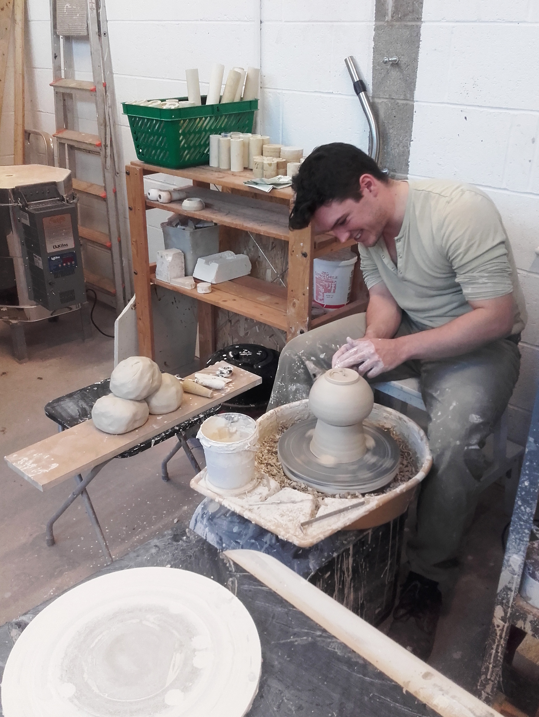
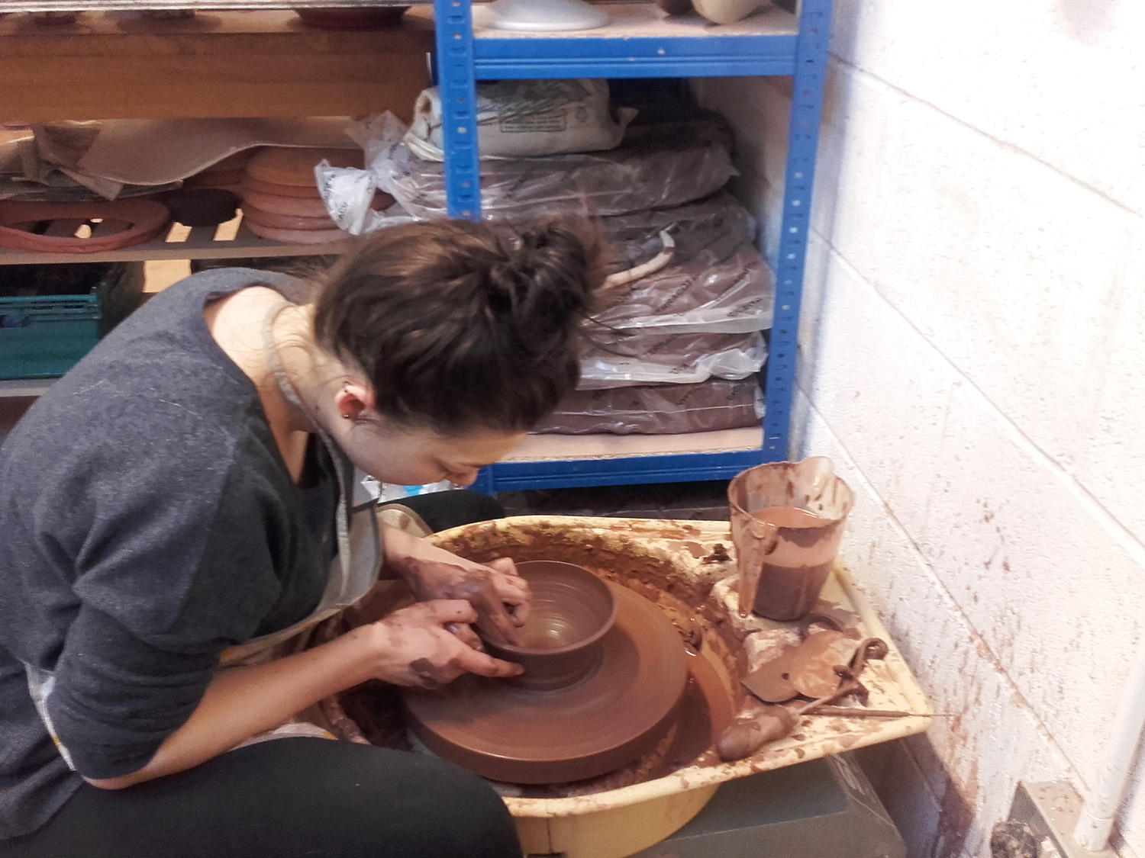
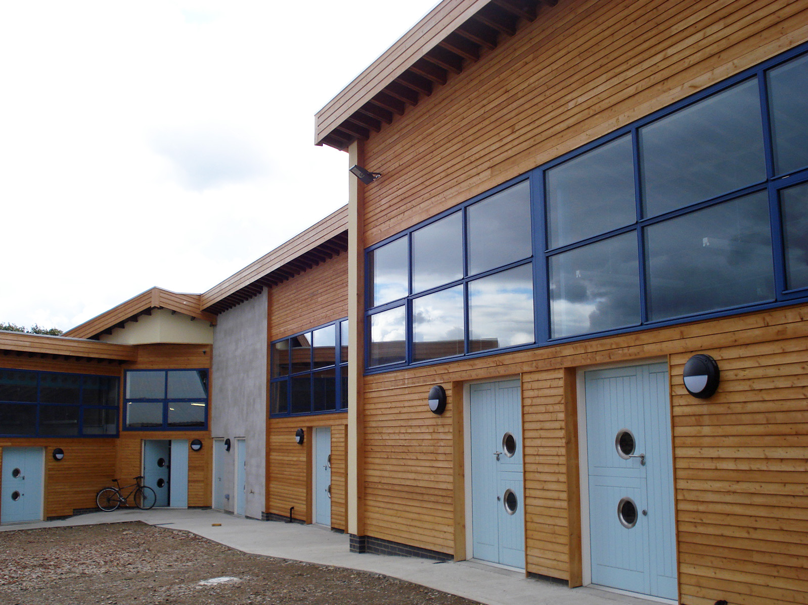
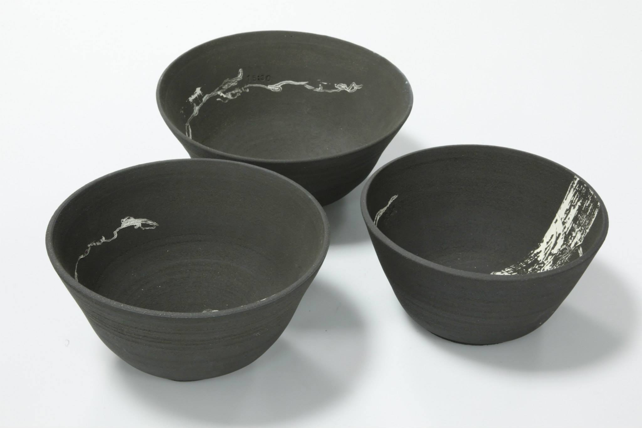
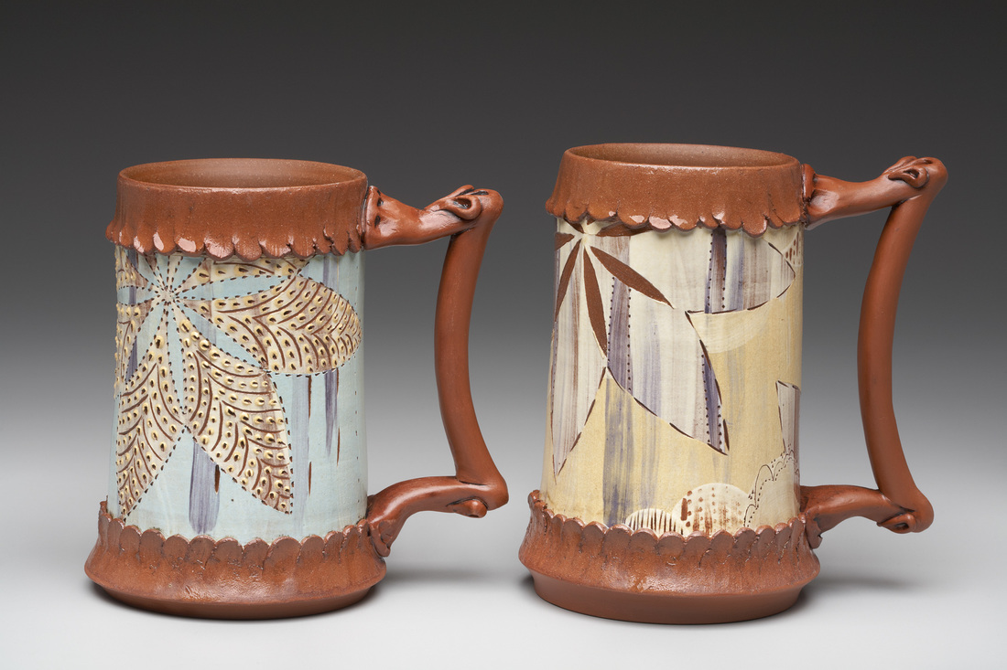
Above: Manor Oaks Studios
Top right: Mike Scown working at the wheel
Right: Bowls by Hannah Staniforth
Below right: Mugs by Victoria Dawes
Below: Hannah Staniforth

- Contact Details:

Name

Address

Telephone Nos. | Day: | Evening: | Mobile:
Email:

Website:
Please give us a brief description of your work and ideas:-
(additional information may be provided on a separate sheet)

2. PDF of visual documentation Please email up to 10 images contained within a PDF document to illustrate your work. Please ensure the document does not exceed 8MB.

Please ensure each image within the pdf document is clearly labelled as follows;
name of piece, year made, materials & techniques used, size (provide photo credit if pictures were taken by someone other than yourself).

- Please give a summary of relevant and recent achievements
Include your educational qualifications, work experience, workshops/projects you attended or have undertaken and any commissions/exhibitions/awards. Continue on separate sheet if necessary.

- What are your long term ambitions and what would you want to achieve during your time on this programme? (we will assess whether you are realistic with your ambitions – please continue on separate sheet if necessary)

- How will you use this programme to achieve this? (we will assess whether we are able to give you the support you need – please continue on separate sheet if necessary)

- Please provide us with names of two referees with contact details (if you are a new graduate, one referee must be a former tutor)

1.

2.

- Completed Equal Opportunities Form (as included on final sheet below).

____________________________________________________________

If you would like to apply for the 2016 – 2018 programme (starting first week of Oct 2016 to end late Sept 18), please return all of the above (points 1-7) and optional additional information (CV, publicity material, artist’s statement) preferably via email (or post if email not possible) to:

Rachael Dodd, Programme Manager,
Yorkshire Artspace, Persistence Works, 21 Brown Street, Sheffield, S1 2BS.
e. rachael@artspace.org.uk
t. 0114 2130111

We will be looking to offer the final place by early September to join the studio with the 3 other starter ceramicists. Applications will considered as they are received, so please don't delay in registering your interest and sending application through.

Equal Opportunities Monitoring Form
Completing this form is optional but doing so will help us meet our commitment to equality of opportunity. The form will be detached as soon as we receive it and filed anonymously. This information will not be shared with third parties.

Which best describes your racial or cultural origins?
Caribbean |  | African |  | Arabic
Indian |  | Pakistani |  | Bangladeshi
Chinese |  | Latin American |  | Irish
British or European |  | Other

Are you: Male Female

0-18
19-24
25-34
35-44
45-54
55-64
65+
Age:

Do you consider yourself to have a disability: Yes No

If Yes, what are your individual needs/requirements? (these can be discussed at interview)

Are you currently in paid work? (inc self-employment): Yes No

Is there anything else related to equal opportunities that you think we should know about?

Explanatory Notes:-
Yorkshire Artspace Society is committed to eliminating discrimination on the grounds of racial group, origin or nationality, sex, disability, religion or age. In accordance with the Disabled Persons (Employment) Act, Sex Discrimination Act, Race Relations Act and the relevant codes of practice, we are carrying out equal opportunities monitoring. This will help us to develop positive action strategies to overcome discrimination. The form will be detached from your application form and will not be used to make decisions about your application for residency, membership, studio space, commissions, workshops or other opportunities. The information will be collated for monitoring purposes and the form will be destroyed. No individual can be identified from this form.

